

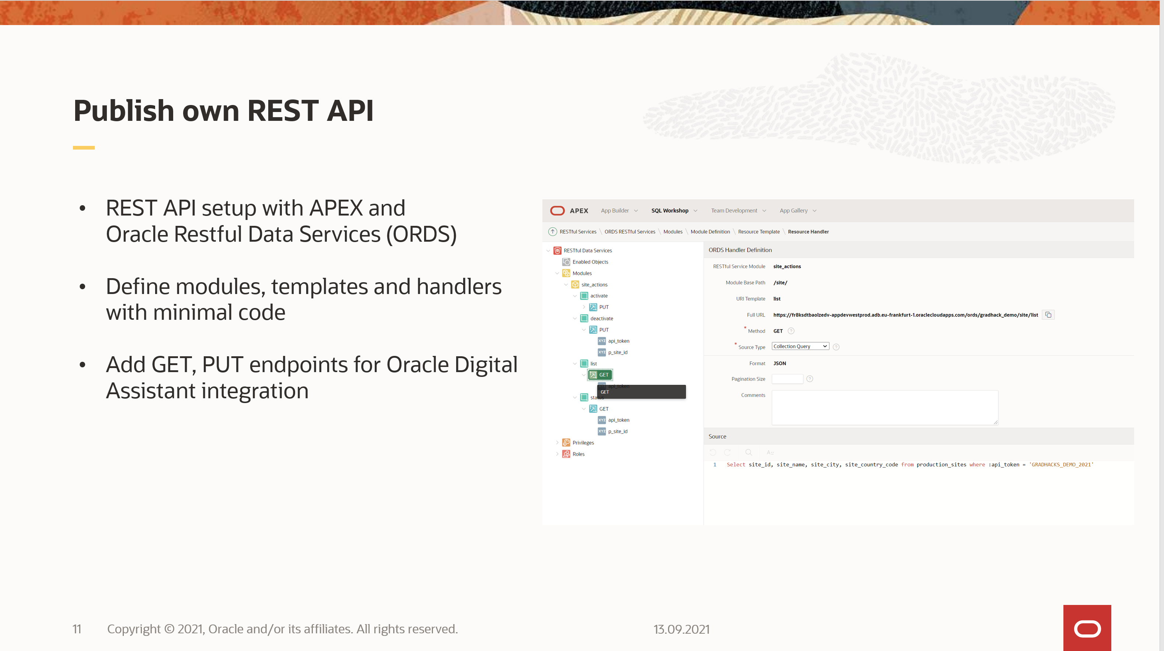

Author: Daniel Ivanescu  
Valid for APEX version 20.2

Steps:

1. Log into your Oracle APEX workspace

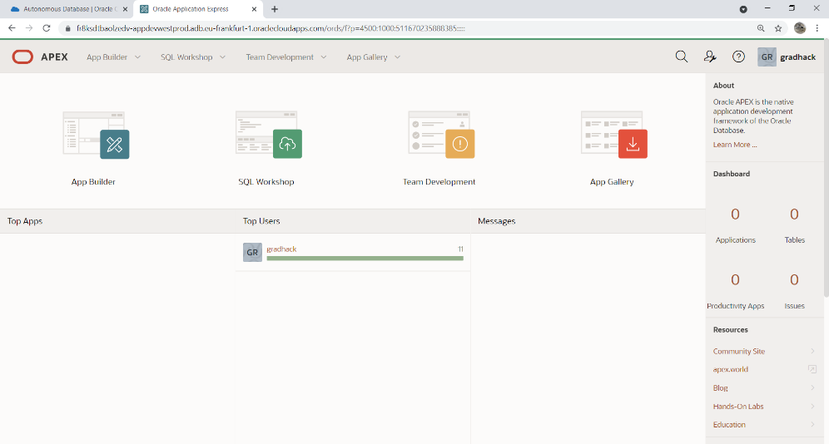

1. Navigate to SQL Workshop > RESTful Services  
   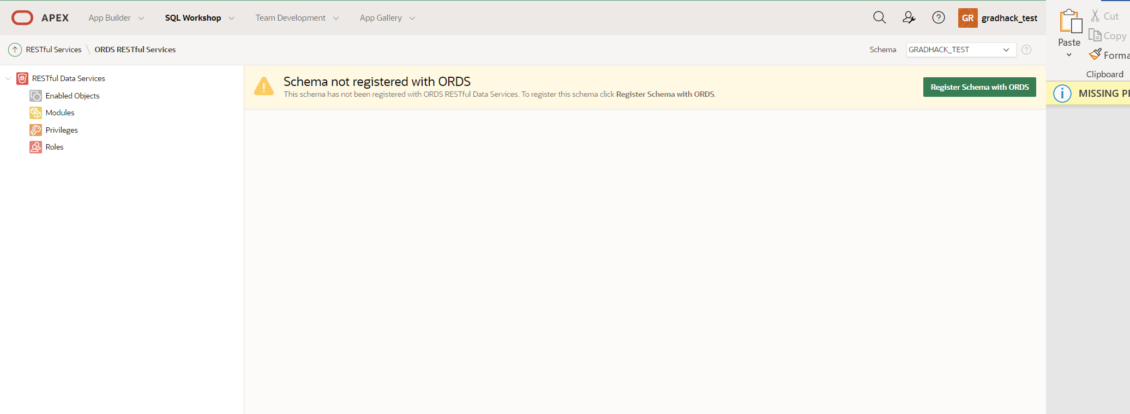
2. Click “Register Schema with ORDS”  
   Click on “Save schema attributes”  
   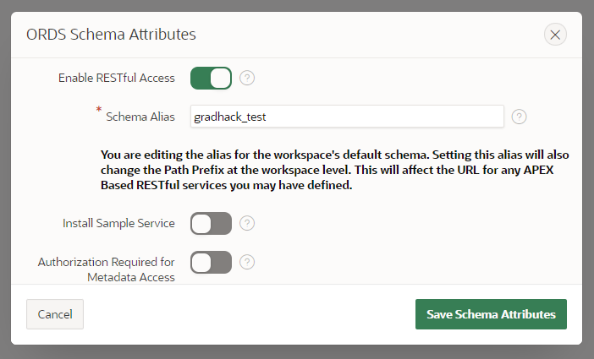
3. Click on Modules  
   Click on “Create module”  
   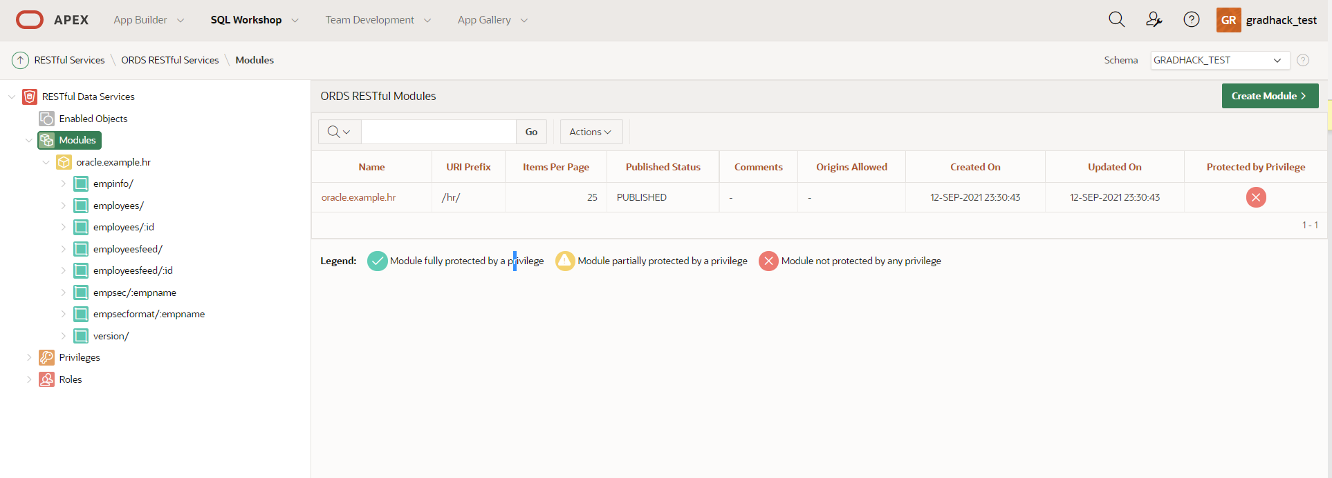
4. Enter module name: Sites  
   Base path: sites  
   Click “Create Module”  
   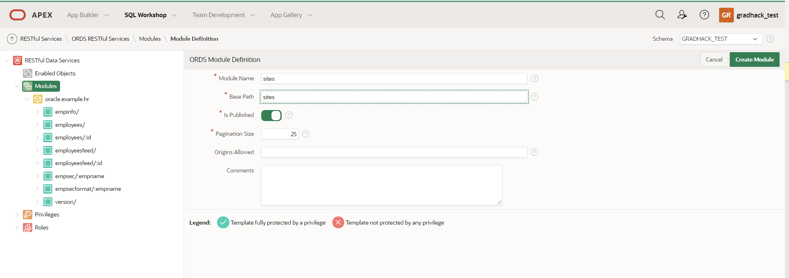
5. Click “Create Template”  
   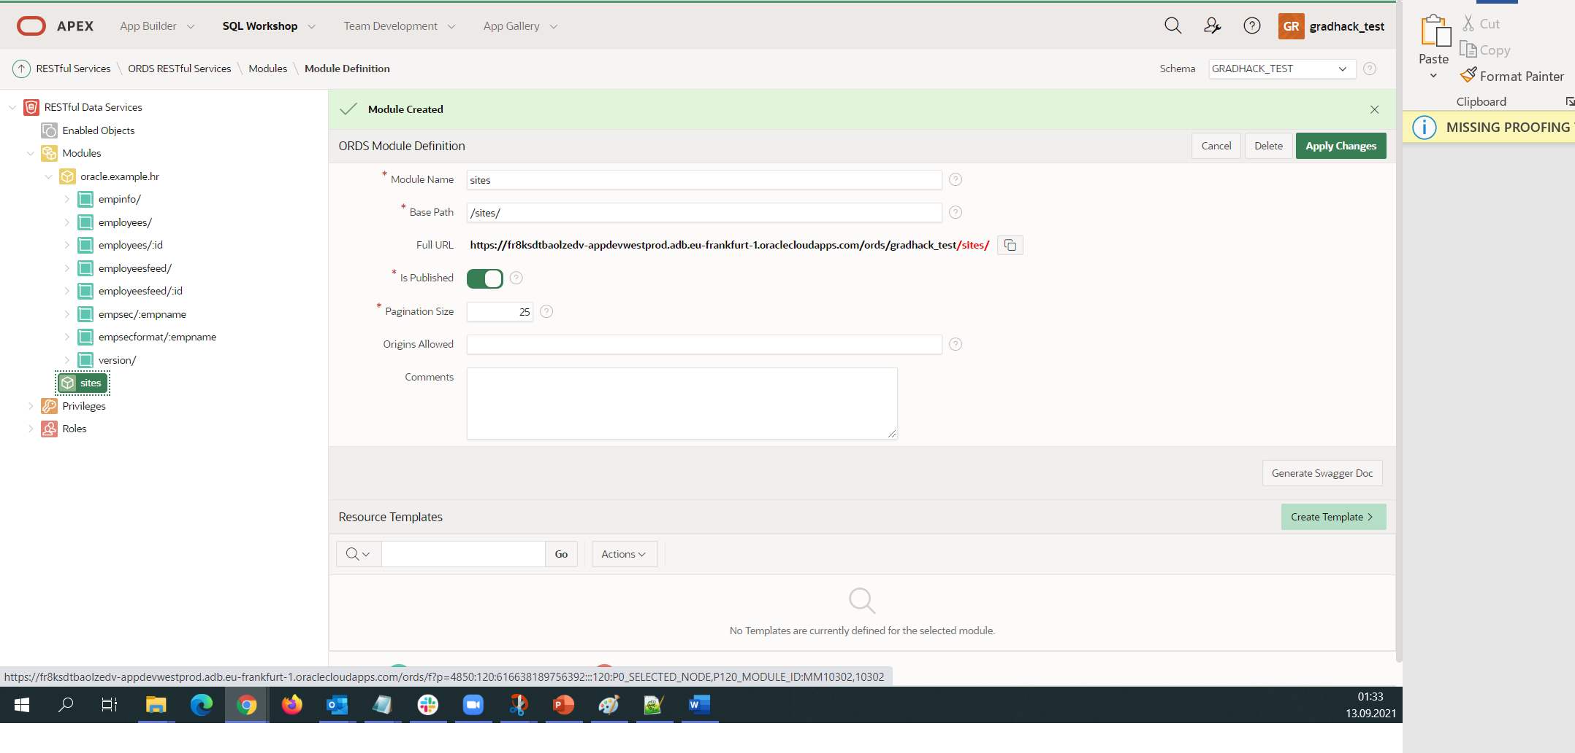
6. Enter URI Template: list  
   Click “Create Template”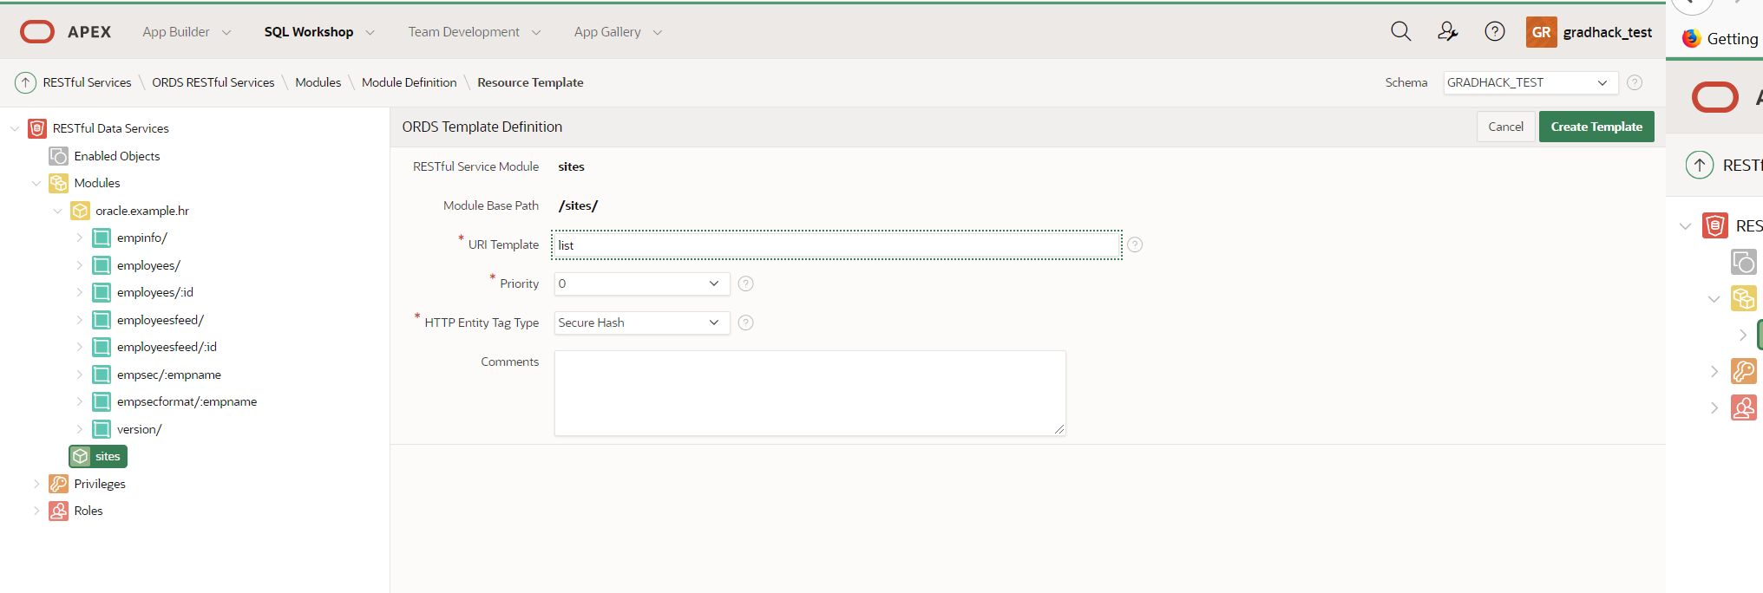
7. Click “Create Handler”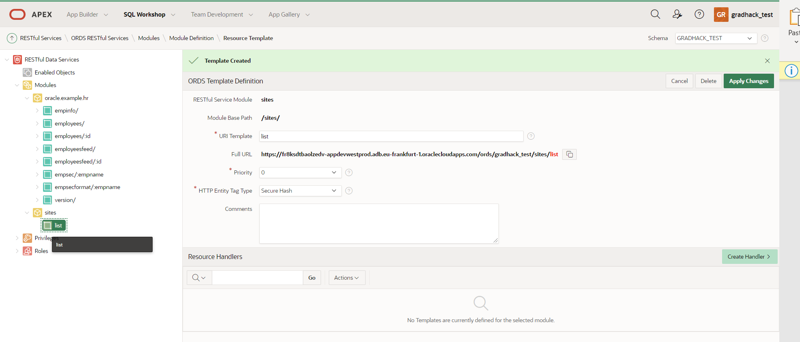
8. Select Method : GET  
   In source region  
    - Enter Source :   
   *Select site_id, site_name, site_city, site_country_code from production_sites where :api_token = 'GRADHACKS_DEMO_2021'*  
   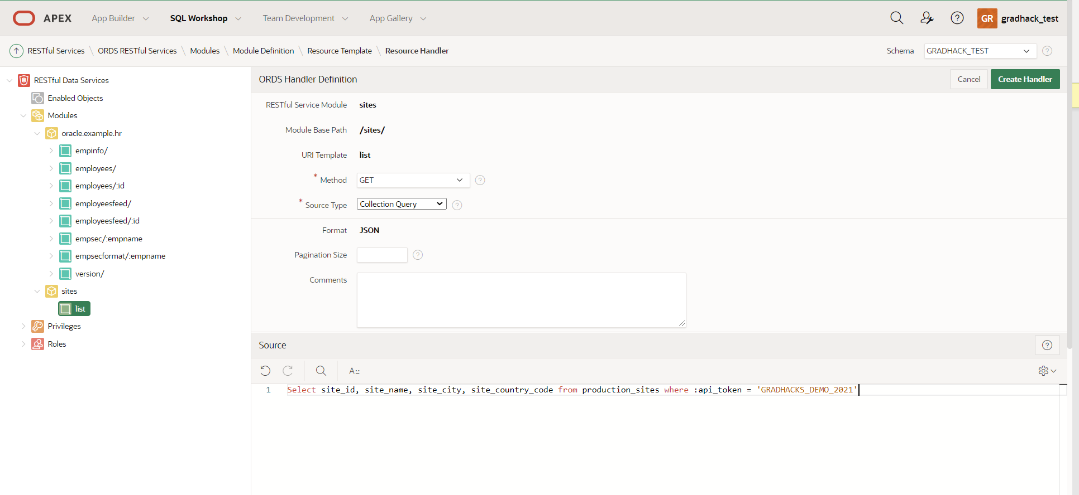  
   In parameters region click “Add Row” and add parameter api_token as follows: 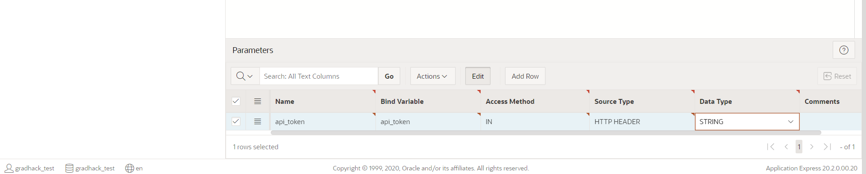
9. Repeat steps 7-9 and create Uri_template: status  
   Method: GET  
   Source: (copied from Production Sites search report)  
   *select PRODUCTION_SITES.ID as ID, PRODUCTION_SITES.SITE_ID as SITE_ID, PRODUCTION_SITES.SITE_NAME as SITE_NAME, PRODUCTION_SITES.SITE_CITY as SITE_CITY, PRODUCTION_SITES.SITE_STATE as SITE_STATE, PRODUCTION_SITES.SITE_COUNTRY_CODE as SITE_COUNTRY_CODE, PRODUCTION_SITES.LAT as LAT, PRODUCTION_SITES.LON as LON, PRODUCTION_SITES.SITE_STATUS as SITE_STATUS, AIR_POLUTION_CURRENT.AQI as AQI, AIR_POLUTION_CURRENT.CO as CO   
   from AIR_POLUTION_CURRENT AIR_POLUTION_CURRENT, PRODUCTION_SITES PRODUCTION_SITES   
   where PRODUCTION_SITES.LAT=AIR_POLUTION_CURRENT."lat"   
   and PRODUCTION_SITES.LON=AIR_POLUTION_CURRENT."lon"  
   and :api_token = 'GRADHACKS_DEMO_2021'  
   and site_id = :p_site_id*Parameters api_token and p_site id as follows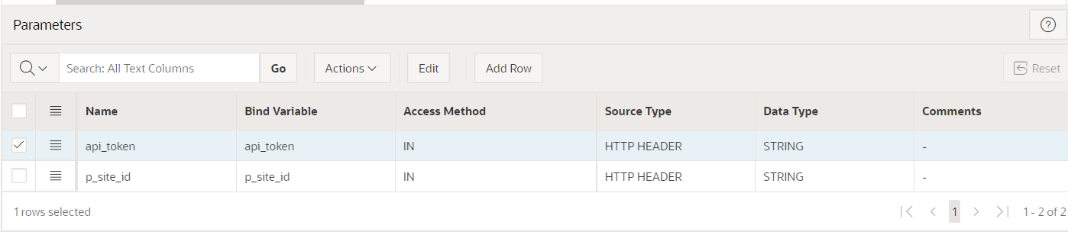
10. Repeat step 7 and create Uri_template: activate  
    Click “Create handler”  
    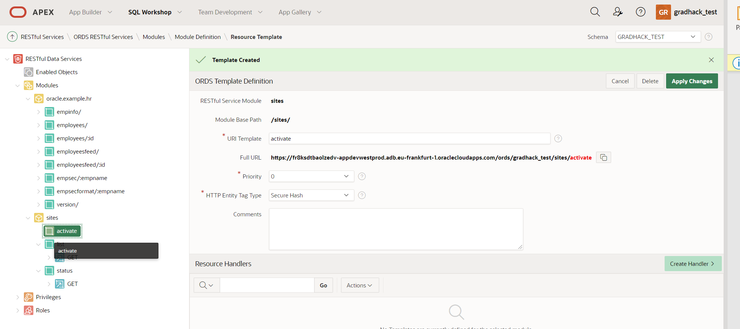
11. Method: POST  
    Source:  
     *begin  
    if :api_token = 'GRADHACKS_DEMO_2021'  
     then  
     update PRODUCTION_SITES  
     set SITE_STATUS = 'active'  
     where site_id = :p_site_id;  
     htp.p('{"message":"Site is now active"}');  
     else  
     htp.p('{"error":"Invalid api_token"}');  
    end if;  
    end;*Parameters api_token and p_site id as follows  
    
12. Repeat steps 11 and 12 and create a template “deactivate” with a POST handler as follows  
    Source code:  
    *begin  
    if :api_token = 'GRADHACKS_DEMO_2021'  
     then  
     update PRODUCTION_SITES  
     set SITE_STATUS = 'inactive'  
     where site_id = :p_site_id;  
     htp.p('{"message":"Site is now inactive"}');  
     else  
     htp.p('{"error":"Invalid api_token"}');  
    end if;  
    end;*  
    Parameters:  
    
13. Test your api by accessing the endpoint full URL and provide your parameters:  
    